Anika Jallipalli

Howard

AP Computer Science 5th

8 January 2019

12.02 Real-World Recursion

***Bumblebee***

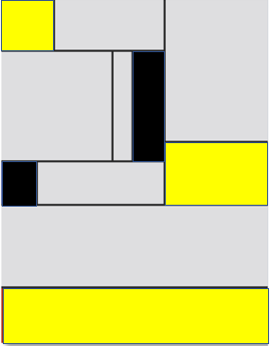

**Explain how you used the principle of recursion to create your image.**

I first divided the space into sections, one would be more simplistic and one more complex. Then I divided the complex space until I thought it was sufficient and divided the simple space into two. Then I added color, so it followed the guidelines.

**Briefly describe a plan for how you might write a program to produce Mondrian art.**

A program can produce the same art by being programmed to start at a random corner of a rectangular figure, this corner is deemed complex and opposite of this corner is deemed simple. Then the program will map vertical and horizontal lines randomly on the complex half of the total object. On the simple side a set limit of 2-4 lines will be mapped. Randomly the program will color certain boxes from the available colors and color the boxes based on the 2:1 ratio.

**Who should get the copyright credit for a piece of computer art: the CPU, the software, or the programmer? Explain your reasoning.**

The programmer should get credit for the piece of computer art. The program is programmed by the program, so what the program produces is a piece of the code created by the programmer. In total the code belongs to the programmer and the artwork is a sequence of code.

**If a computer, with no human intervention, produced Mondrian art indistinguishable from an original masterpiece, would it be a sign of artificial intelligence?**

In my opinion, no. The code allowing this art to be created is a sequence of random steps meaning there is not actually intelligence needed to produce the artwork. All the intelligence was provided by the creator of the code.

**If a computer, with no human intervention, produced Mondrian art indistinguishable from an original masterpiece, would it diminish the accomplishments of a human?**

No. This is because the code is created so the art is always a different piece. This is produced by the programmer and the code they provided. If anything, it proves how intelligent the human is.